Show What You Know

Activity Design
Todd Van Ritchie

EDUC5105: Designing Distributed Learning
Dr Lisa O’Neil
June 4, 2021

Who are my students?

I teach elementary physical education. My students range from Primary to Grade 5 (though this year I only teach up to the Grade 4s and another educator teaches the Grade 5 classes). For the purpose of this lesson, I am going to focus on the Grade 4 level. This gives me a group of approximately 60 students in 3 separate classes (two grade 4 classes and a 4/5 class). All of the students are currently signed up for my Grade 3 Google Classroom. Moving into the 2021-22 year I will be renaming this classroom as my Grade 4 Online PE Classroom; old content will be removed, and it will be set up for the upcoming school year. All students are familiar with navigating the Google Classroom.

What Content Needs to Be Covered?

The focus of this assignment is to share their learning in an e-portfolio type manner. Using Google Slides students will create a slide show of their learning with respect to a single skill covered during the current term of learning.

The specific outcome covered by the assignment will depend on the skill selected by the students. Every term of the year includes Dance, Gymnastics and Games/Sports.

Outcome 3, 4, or 5: Students will demonstrate competency in fundamental movement skills and movement concepts within either dance (3), gymnastics (4) or games/sports (5).

What are the Desired Outcomes from the teaching? (What skills are developed)

Outcome 3 Indicators of Learning:
- 4.3.7 Perform and/or create a pattern of dance steps and movements (e.g., skip, swing, do-si-do, body rolls) in a variety of formations (e.g., trios, small groups, parallel lines) while maintaining rhythm.
- 4.3.9 Demonstrate creative expression, valuing risk taking as a component of the creative process of dance

Outcome 4 Indicators of Learning:

- 4.4.2 Demonstrate consistency and control of movement (e.g., maintain center of gravity in tripod balance)
- 4.4.3 Combine locomotor skills, non-locomotor skills, and movement concepts (e.g., travelling, rolling, balancing, weight transfer) to perform simple movement sequences in a variety of rhythmic activities
- 4.4.6 Demonstrate weight transfer (e.g., cartwheel, round off)
- 4.4.7 Demonstrate fundamental movement skills using two or more movement patterns in a sequence with small apparatus

Outcome 5 Indicators of Learning:
- 4.5.2 Engage consistently and constructively within a variety of games, focusing on applying movement skills and concepts
- 4.5.3 Demonstrate an understanding of body awareness and orientation (e.g., ready position for serve reception or individual defensive play)
- 4.5.5 Combine skills (locomotor, non-locomotor, and manipulative) with appropriate effort (e.g., time, force, and flow) to expand the development of individual skills

What Instructional Strategies will I use?

Instructional strategies are techniques teachers use to help students become independent, strategic learners. These strategies become learning strategies when students independently select the appropriate ones and use them effectively to accomplish tasks or meet goals. To meet the needs of this assignment I will need to use Direct Teaching, and Teacher Feedback as strategies to assist in the learning. The students will also be involved in Self-Feedback and Divergent Discovery as part of this process.

Direct Teaching – students will be walked through the entire assignment in their first lesson, subsequent lessons will allow for further direct teaching about the process of selecting their skill, planning their presentation, and creating the digital recordings and presentation.

Teacher Feedback – students can share digital recordings of their skill prior to creating their slides doc to receive feedback on the skill performance and on the video itself.

Self-Feedback – students use the materials provided in the PE Google Classroom that detail performance criteria for skills in order to evaluate their performance and share these results in their slides presentation.

Divergent Discovery – students have an assignment that has multiple solutions and are encouraged to create their own solution

What technologies/tools might help with the presentation or content, execution of instructional strategies identified, or support learning activity?

In order to share this assignment, I will require the use of the LCD projector and Chromebook, a Google Classroom, Google Slides and a recording device.
In order to complete this assignment, the students will require the availability of a Chromebook for each student, access to the Grade 4 PE Google Classroom, access to a recording device either at school or at home (mobile phone, tablet, Chromebook).

What principles must be considered during the development of the identified technologies/tools for their most effective use?

Equitable Access is key to this assignment. Currently in my school all Grade 3-5 students are assigned their own Chromebook for the duration of the school year. With the assumption that none are damaged during the timeframe of this assignment all students will have equitable access to the necessary technology required.

Pre-existing Student Learning is also a key to this assignment. In grade 3 during the 2020 school year Google Slides was used often in classroom assignments. This should provide the students with the basis of knowledge to operate the Google Slides program at its most basic levels – opening, inserting media, inserting text. Additionally, students have used the camera features on their devices.

Physical Education Technical Information such as proper techniques and skill cues will be provided to students in their Google Classroom throughout the term as skills are introduced. These resources would then be available to the students for reference when completing this assignment.

Educational Technology How-To Support will be provided in their google classroom with video support of how to do the necessary things in Google Slides, how to use the Chromebook camera to take pictures and videos, and how to import videos from another device into their google drive in order to insert them in their slide’s presentation.

Lesson Plan

Topic
Demonstration of student learning based on the skills taught during the selected term. Students will create a presentation to “Show What You Know”. The presentation will include a title slide, a slide with a video of the student performing their chosen skill and a brief explanation of the skill being demonstrated.

General Outcomes
- Students will combine skills (locomotor, non-locomotor, and manipulative) with appropriate effort (e.g., time, force, and flow) to expand the development of individual skills.
- Students will create and publish digital work that represents their learning in Physical Education.

Specific Outcomes
Dependant on Skill selected by the students.

Dance: 4.3.7 and 4.3.9
Gymnastics: 4.4.2, 4.4.3, 4.4.6, and 4.4.7
Games/Sports: 4.5.2, 4.5.3, and 4.5.5

Cross Curricular
Information and Communication Technology Curriculum

Productivity:
1.1.4: Students will be expected to use grade-appropriate digital tools to plan, organize, and represent their learning for various purposes and audiences, both individually and collaboratively

Learning Objectives
- Students will be able to select a skill learned during the term and present their learning
- Students will be able to physically perform the skill(s) learned during the term and explain the basic cues and discuss their level of skill and success.
- Students will be able to use appropriate digital tools to create and share their learning

Equipment/Materials
- Students will require any necessary equipment to perform their skills
- Digital recording device – iPad, Chromebook, digital camera.
- Chromebook – Grade 4 PE Google Classroom access, Google Slides

Teacher Activities
Pre-Lesson Planning:
- Set up assignment in Grade 4 PE Google Classroom
- Prepare an example of the expected work
- Share assignment with Grade 4 Classroom teachers so that they are aware of the assignment and can reinforce the need to complete it during available classroom time.

Lesson Delivery:
- Using the LCD projector share the Google Classroom assignment at the start of a PE class.
- Review the concepts behind the assignment, the expectations and the assessment of the assignment.
- Share a sample Google Slides project that is completed for students to review.
- Set a date for completion of the assignment and submission through the Grade 4 PE Google Classroom.

Follow up:
- Review expectations at subsequent PE classes.

Extension

Students interested in extending their learning in this activity can choose one of the following options:

- Include slides in the presentation that demonstrate their chosen skill at a professional level. (e.g.: skill selected is tossing and catching – include slides with baseball video/pictures and related information regarding throwing and catching technique and cues as seen in the video.)
- Include slides of the student doing a second skill not related to PE class but of a more personal nature to the student. (e.g.: a community hockey player may include slides based on their hockey performance – video of game play…, a dancer may include dance recital video…)

Differentiation

Students with adaptions to their physical education program will create content based on their adapted program with the assistance of their Learning Centre teacher, their EPA, the PE teacher, and/or their classroom teacher as available or required.

Students will use their Google Classroom resources created based on their adaptations to guide their assessment and evaluation of their skill performances.

Assessment

Skill performance assessment to be completed by the students within the assignment will be based on the appropriate skill rubrics in the Gr 4 PE Google Classroom. See sample Rubrics below.

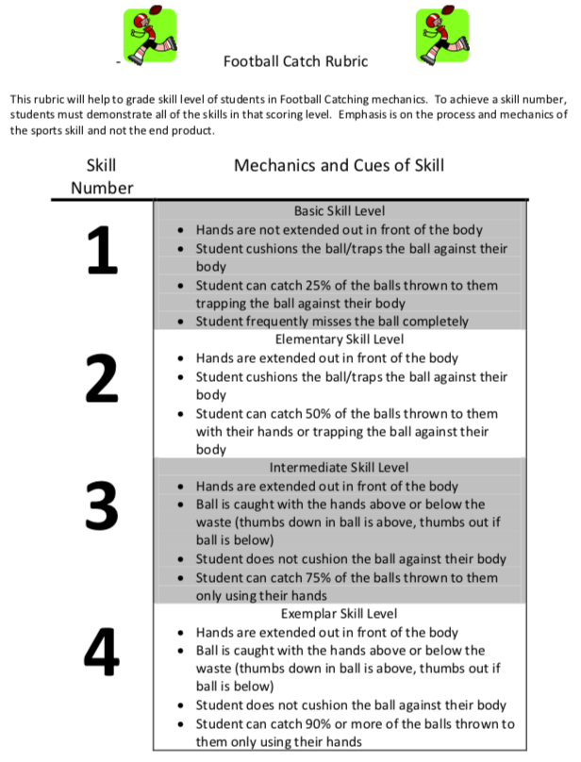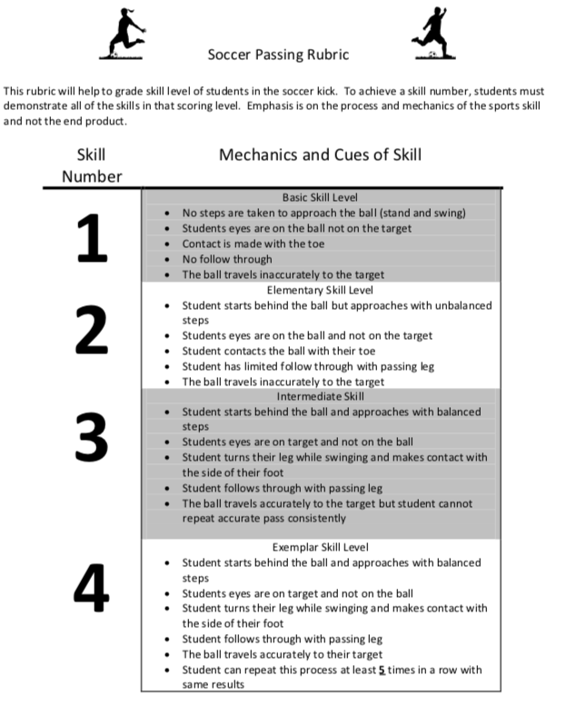

The assignment itself, will be assessed based on the following criteria:

Google Slides Rubric:

Student Name _________________________ Class_________________

Score | Required Elements | Media | Text | Appearance
 | Needs Development – Basic Skill Level
1 | Several required elements were missing. | Media do not relate to the topic. | Text has many errors and is not related to the topic. | The google slides are distractingly messy or very poorly designed. It is not attractive.
 | Developing as Expected – Elementary Skill Level
2 | All but 1 of the required elements are included on the google slides. | All media relate to the topic. | All text is related to the topic, some errors present. | The google slides are acceptably attractive though it may be a bit messy.
 | Developing as Expected – Intermediate Skill Level
3 | All required elements are included on the google slides. | All media are related to the topic and most make it easier to understand. | All text is related to the topic and can be understood. | The google slides are attractive in terms of design, layout, and neatness.
 | Well Developed – Exemplar Skill Level
4 | The google slides include all required elements as well as additional information. | All media are related to the topic and make it easier to understand. | All text is related to the topic, clear, grammatically correct and easy to understand. | The google slides are exceptionally attractive in terms of design, layout, and neatness.

Sample Presentation

Slide 1 – Title Slide  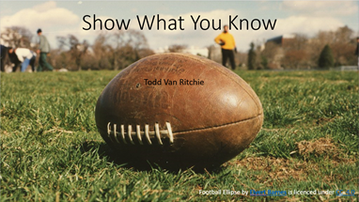 | Slide 2 – Skill Slide
Slide 3 – Extension Activity #1 – Professional  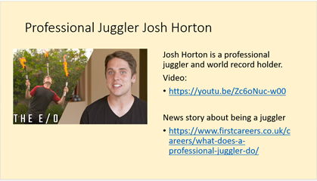 | Slide #4 – Extension Activity #2 – Personal
Resources

Government of Nova Scotia. (2015). Physical Education Grade 4-6 Streamlined Curriculum. Retrieved from https://www.ednet.ns.ca/files/curriculum/physed_4-6_streamlined.pdf

Government of Nova Scotia. (2015). Learning Outcomes Framework Grades P-6. Retrieved from https://www.ednet.ns.ca/files/curriculum/P-6LOFs-Oct1-2015.pdf

PHE Canada. (2020) Physical Education Instruction. Retrieved on June 1, 2021 from https://phecanada.ca/activate/return-school-phe-guidelines/physical-education-instruction

Support Real Teacher. (n.d.) Teaching Styles in Physical Education. Retrieved on June 4, 2021 from https://www.supportrealteachers.org/teaching-styles-in-physical-education.html

